Cellular Respiration | Cellular Respiration
Cellular Respiration | Lysosome
Prokaryote | Prokaryote
Prokaryote | Prokaryote

Aerobic Process Uses Oxygen | Converts food energy into ATP Energy
Digestion, waste | Job of the mitochondria
Which type of cell  Unicellular | Which type of cell  No Nucleus
Which type of cell  Circular DNA | Which type of cell  Bacteria

Prokaryote | Eukaryote
Eukaryote | Eukaryote
Eukaryote | Eukaryote
Cell Wall | Cell Membrane

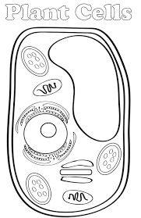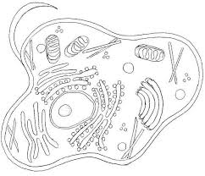 | 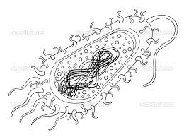
Which type of cell  Mostly multicellular  Some unicellular | Which type of cell  Nucleus
Which type of cell  Linear DNA | Which type of cell  Everything but bacteria
Outer boundary  Controls what enters and exits cell | Only in plants, Gives structure and protection

What organelles are in all cells | Only found in Eukaryotic cells
Only found in Prokaryotic cells | Only found in plants
Chloroplast | Chloroplast
Chloroplast | Chloroplast

Nucleus, membrane bound organelles, linear DNA | Cystoplasm  Cell membrane  DNA, Chormosome, Genetic material, ribosomes, lysosome
Chloroplast, cell wall, large central vacuole | Circular DNA
Converts energy, only in plants | Pancakes
Converts radiant energy from the sun into chemical energy glucose | Responsible for photosynthesis

Photosynthesis | Cellular Respiration
Photosynthesis | Cellular Respiration
Vacuole | Vacuole
Vacuole | Cytoplasm

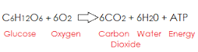 | 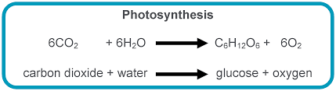
Energy conversion that begins with glucose | Energy conversion that begins with CO_{2,} Carbon Dioxide
Stores water and nutrients | Larger in plants
Holds all of the organelles in place | Smaller in animals

Cytoplasm | Cytoplasm
Mitochondria | Mitochondria
Mitochondria | Mitochondria
Nucleus | Mitochondria

Gel/Jelly substance in all cells | In all cells, aqueous solution
Converts food energy to ATP energy | Energy factory
Responsible for this process of cellular respiration
Responsible for the aerobic (uses oxygen) process in cells | Only found in Eukaryotes

Nucleus | Nucleus
Ribosomes | Photosynthesis
Chloroplast | Photosynthesis
Aerobic | Anaerobic

Control Center, The Brain | Holds the genetic material, DNA, Chromosomes
The process that occurs inside the Chloroplast | Proteins  Amino Acids  Polypeptides
Anaerobic (no oxygen) process | Responsible for energy conversion inside the plant cell
Does not use oxygen  Photosynthesis in the chloroplast | Uses Oxygen (Cellular Respiration in the mitochondria)

Something all cells have in common
Convert food to energy to sustain life.

